**Leap Year**

A year is a leap year if the following conditions are satisfied:

1. The year is multiple of 400.
2. The year is multiple of 4 and not multiple of 100.

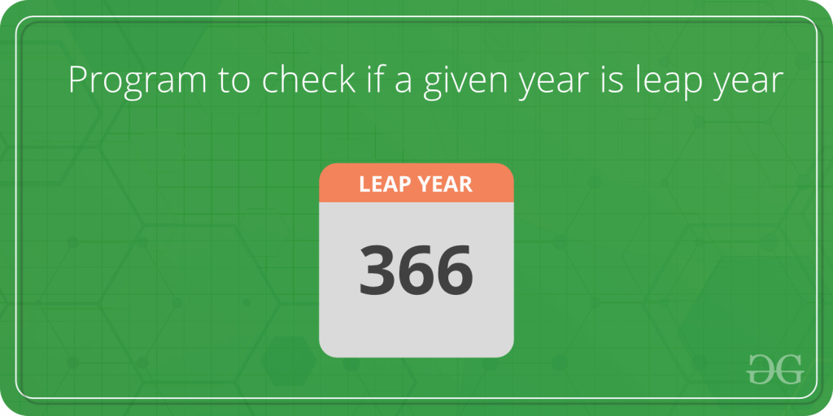

C++

#include<iostream>

using namespace std;

int main()

{

int year;

cin >> year;

if(year % 4 == 0 and year % 100 != 0)

{

cout << "Leap Year";

}

else if(year % 400 == 0)

{

cout << "Leap Year";

}

else

{

cout << "Not a Leap Year";

}

return 0;

}

**INPUT :**

2324

**OUTPUT :**

Leap Year